CIDM 6341-01 Current issues in Cybersecurity

Mariam Adegbindin

Buff ID: 1133249

Shields Up

**Question 1: What did you do?**

I proceeded to download the file into their PC and subsequently stored it within the designated download directory. I then proceeded to eliminate the file, causing it to be transferred to the recycling bin. I restored the file from the recycle bin, just to subsequently delete it once more, and ultimately eradicate it permanently from the recycle bin. Recuva is a software application that can be utilised to retrieve files that have been permanently deleted. Additionally, the CC cleanser can be employed to thoroughly eliminate files from the recycle bin, thus ensuring their permanent deletion from the system and preventing any possibility of recovery.

**Question 2: What were the results?**

Upon removing the file from the download folder, it was subsequently relocated to the recycle bin, and I was able to successfully restore it back to its original location in the download folder. However, on attempting to permanently delete a file from the recycle bin, I encountered an inability to restore the file using the Recuva application. The Recuva application was configured to do a comprehensive search across all file types within the computer system, encompassing all areas of the computer. Additionally, a separate search was initiated specifically targeting files that had been deleted from the recycle bin. Additionally, an attempt was made to locate the file within a designated place, namely the download folder.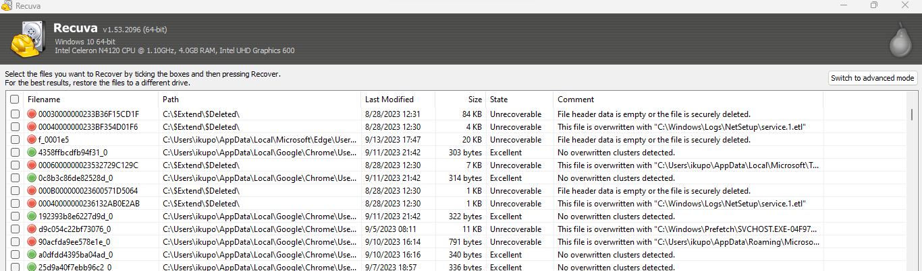

*Files recovered after running “Recuva”*

The findings consistently indicated the absence of the dilbert_security file, which had been removed. The outcomes obtained through the execution of Recuva software revealed a substantial number of files with timestamps dating back to the year 2022. Recuva categorises files into three distinct states: "Unrecoverable," denoted by a red colour, "Poor," indicated by a yellow colour, and "Excellent," represented by a green colour. I successfully retrieved files in all three states. However, the PNG file that was in an unrecoverable state remained inaccessible even after the recovery process. A screenshot of a computer

*A file received with Recuva in an “Unrecoverable state”*

The Word document, which was in a deteriorated condition as observed in Recuva, was successfully opened. However, the content was fragmented and consisted primarily of characters rather than coherent words.A screenshot of a computer

*A file received with Recuva in an “Poor state”.*

The recovered file, which was found to be in an optimal condition, was accessed and opened using Microsoft Word. However, the material appeared to lack coherence, potentially due to the inappropriate file format for opening it. Nevertheless, it was still possible to partially read and grasp the text, in contrast to another file containing characters instead of words.A file received with Recuva in an Excellent state


*A file received with Recuva in an “Excellent state”.*

Upon executing the ccleaner tool on the recycle bin, the Recuva software failed to retrieve the deleted files.

**Question 3: What did you learn?**

When a file is deleted, the operating system designates the region on the hard disc drive (HDD) where the data is stored as accessible, and then eliminates it from the hierarchical file system. The magnetic data remains stored on the disc; however, the method to retrieve the data has been eradicated from the operating system. Data retrieval programmes such as Recuva, developed by Piriform, can recover deleted files by doing a thorough scan of the disc to identify magnetised parts. These applications make an effort to reconstruct lost files, even if only a portion of the file can be restored. Despite the incomplete restoration, the recoverable data can still be successfully accessed and read.

These tools can provide significant advantages to enterprises seeking to securely erase files through the utilisation of the cleaner, as well as to those aiming to retrieve inadvertently deleted files by employing recuva. The efficacy of this technology in permanently eradicating unrecoverable sensitive information would vary depending on the company and its specific industry.